Help! Lost Male Short-Hair Tabby Cat with Dark Markings and Circular Pattern on Side


Last seen on April 25th at 525 Matadero Ave.
If seen, please call 650 575-4609 or 650 776-6873
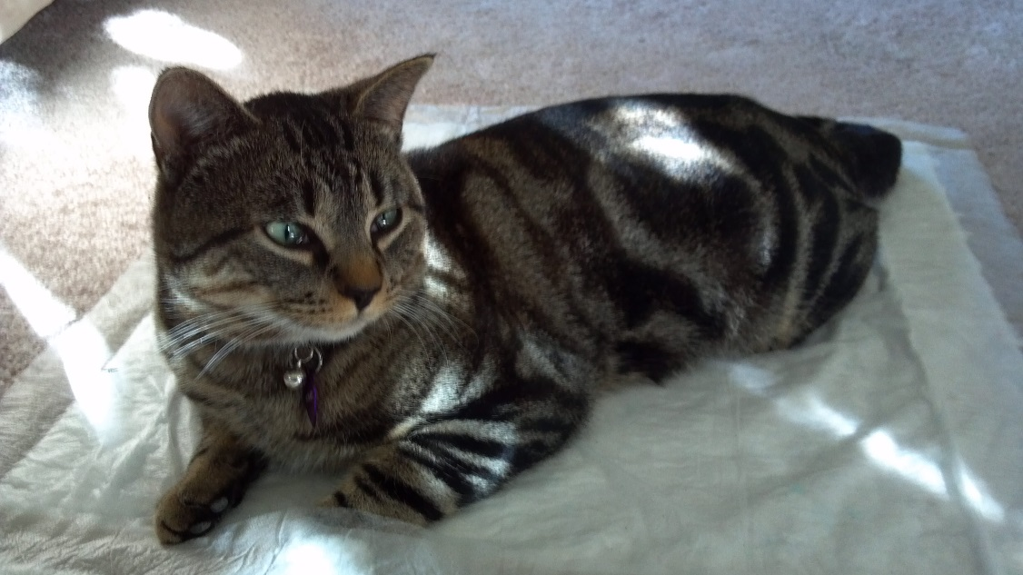
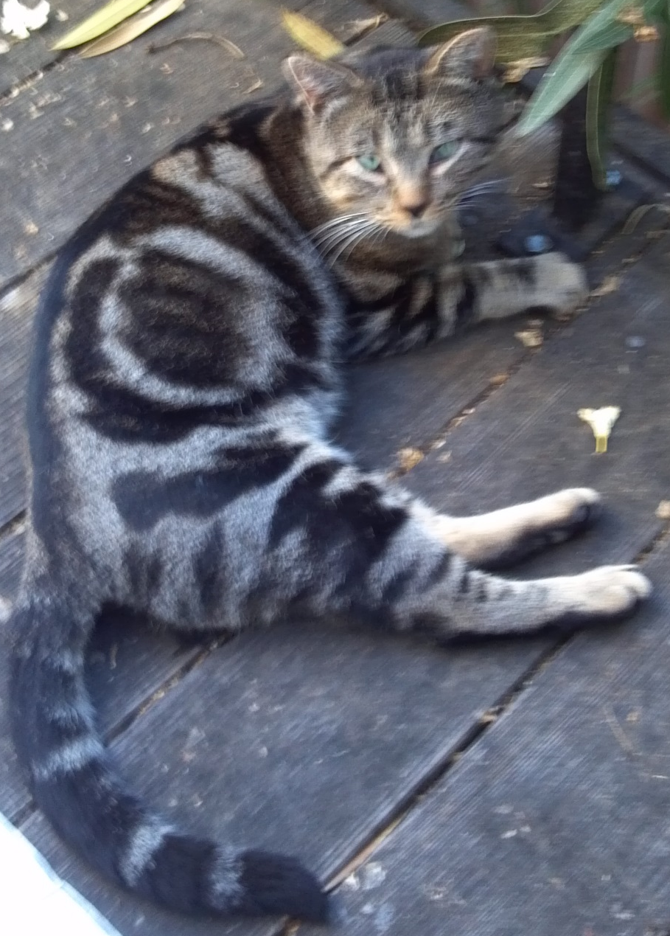
Help! Lost Male Cat
- Short-Haired Tabby
- Dark Markings
- Circular Pattern on Side
Last seen on April 25th at 525 Matadero Ave.
If seen, please call 650 575-4609 or 650 776-6873

